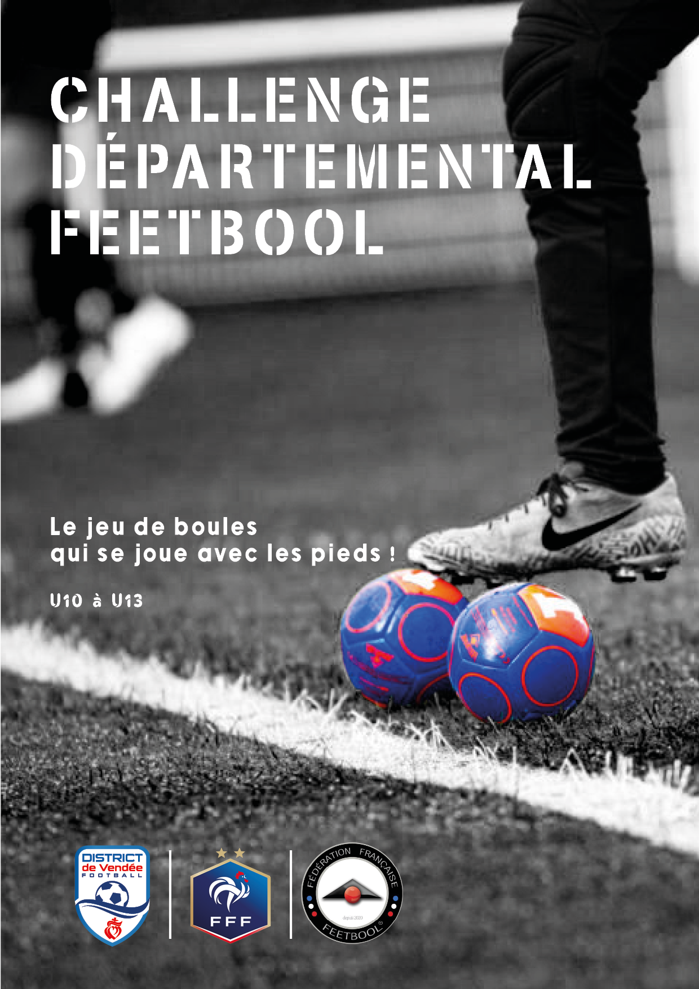

***Phase de qualification***

DATE

**LOGO CLUB**